**LIVE ARRIVALS (City: Dublin, IATA Code: DUB and Airport: Dublin ) at 17:41 on 18th Oct 2016**

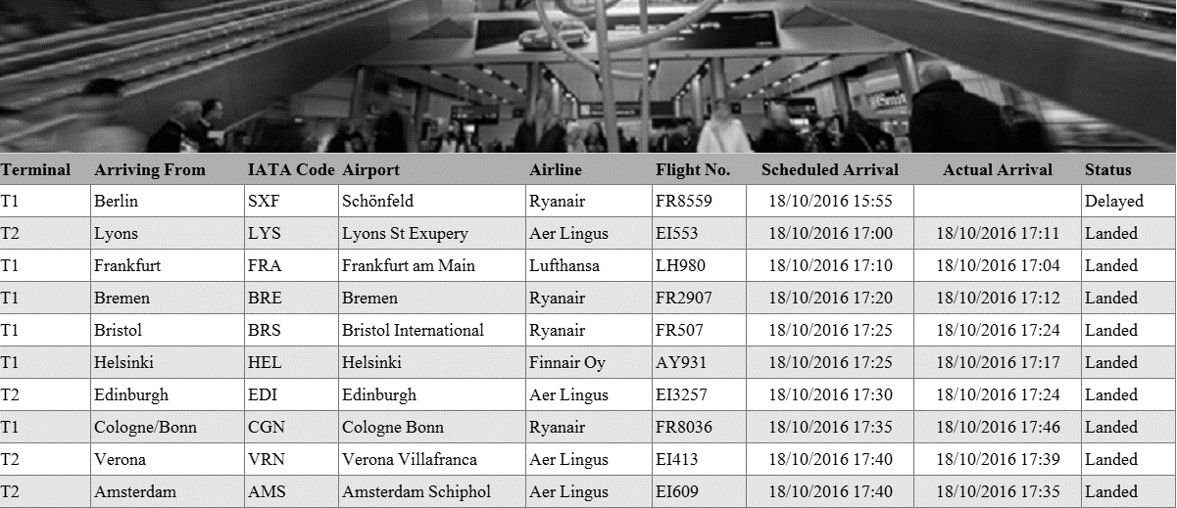

Figure 1 Arrivals in Dublin Airport

The image in Figure 2 shows flights arrival status into Dublin Airport (City: Dublin, IATA Code: DUB and Airport: Dublin) at 17:41 on 18th October 2016. The box to the left of each row shows the terminal into which the flight will arrive (T1 = Terminal 1, T2 = Terminal 2). The details shown are the city of origin, the Airport IATA code and name, the airline, the incoming flight number, the day and time on which the flight was scheduled to arrive, the time at which the flight landed (if it landed) or blank (if it has not landed). The flight status will be shown as delayed if the flight is overdue and has not landed. Flights that are not due to have landed are not shown. The same system is used throughout the world.

For normalization you may assume the following information holds. Other airports could have arrivals recorded in the same database. The IATA is unique for the airports that are recorded (i.e. no two airports in the database have the same IATA code. A flight number uniquely identifies the departure and arrival airports (e.g. FR2907 always flies from Bremen to Dublin) and the arrival terminal. The flight instance is uniquely determined by the flight number and scheduled arrival time. The list is generated depending on the current local time, which is not stored in the database, but is generated at run time. You need not take into account the fact that the flight prefix determines the airline.

3. (a) Represent the data shown in Figure 1 in unnormalized form. (5 marks)

(b) Represent the form(s) derived in part (a) in first normal form. (5 marks)

(c) Represent the form(s) resulting from part (b) in second normal form. (5 marks)

(d) Represent the form(s) resulting from part (c) in second normal form. (5 marks)

(e) Represent the form(s) resulting from part (d) as an ERD. (10 marks)